No. of Pages | 5
No. of Questions | 8

Department of Computer Science and Engineering
FINAL EXAMINATION SPRING 2010

CSE320: Data Communications
Total Marks: 90 Time Allowed: 3 Hours

- Answer Any Six (6) questions out of Eight (8) questions.
- Figure in bracket [] next to each question indicates marks for that question.

Question No. 1

  - What is the TCP/IP model? Why do we use it? [3 marks]
  - You write www.tinbaktu.org in the web browser’s URL box and press enter. Your network’s DNS server did not have the IP address of the URL initially. But you were still able to access the site? How is it possible? [4 marks]
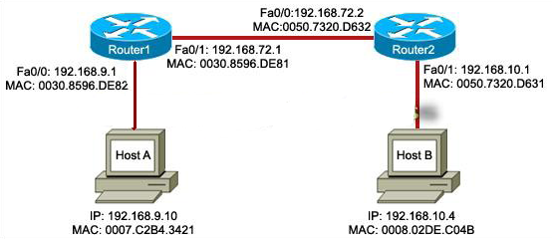
  - Host A is sending data to Host B in figure no.1. State the destination and source IP addresses and MAC addresses that will be included in the packet sent by Host A? [3 marks]
  - Compare HTTP and FTP. [3 marks]
Figure No. 1
  - What does the output below in figure no. 2 represent? [2 marks]
C:\> nslookup
Default Server: resolver1.xyz.local
Address: 10.10.10.32
>www.abcd.com
server: resolver1.xyz.local
address: 10.10.10.32

Figure No. 2

Question No. 2

- Telnet application uses TCP but not UDP. Why? [3 marks]
- Client A starts the initial connection with server B by sending a SYN message with SEQ number 200. Draw the complete process with appropriate flags and sequence numbers and also name the process. [4 marks]

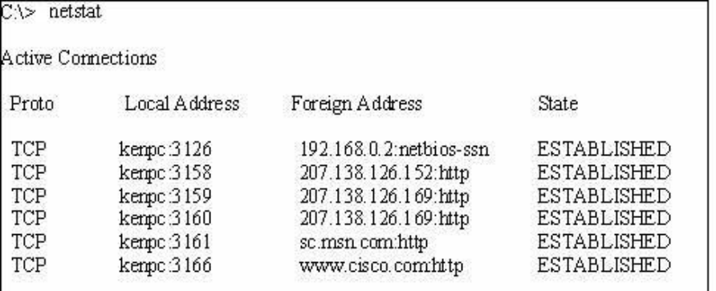
Figure No. 3
- In the above output (figure no. 3), what kind of port numbers are being used in the 2nd entry? Explain the 2nd entry briefly. [4 marks]
- The source host sends segments with sequence numbers 2000 to 3999. None of them arrive at the receiver. What happens next? Explain the purpose of sequence numbers using the example given. [4 marks]

Question No. 3

Host IP address/subnetmask : 10.100.132.200/26
Network address
Broadcast address
First usable host IP address
Last usable host IP address

- Complete the above table. [5 marks]
- What is the purpose of using public and private addresses? [3 marks]
- What is a routing protocol? What are the advantages of using a routing protocol rather than configuring all routes manually? [4 marks]
- When would a router use a default route? What happens to packets if a router does not have a default route configured? [3 marks]

Question No. 4

- Why do we use Single Mode Fiber Optic cable for long distance communication?[3 marks]
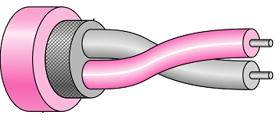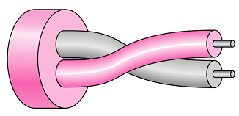
Figure No. 4a
Figure No. 4b

- What does the above two figures (figures 4a and 4b) represent? Compare the cables. Why are the wires twisted? [4 marks]
- How does the cladding in a fiber optic cable help the light to stay within the core?[3 marks]
- When do you use a Straight-Through cable and a Cross-Over cable? [3 marks]
- What do ILD and LED stand for? Where are they used? [2 marks]

Question No. 5

- Draw the send and receive window of Go-Back N ARQ, where m=3. [4 marks]
- In Selective Repeat ARQ, explain what will happen after a Negative Acknowledgement (NAK) for a particular frame is lost during transmission. [3 marks]
- When do we use piggybacking? [2 marks]
- Why is Go-Back N ARQ better than Stop and Wait ARQ? [3 marks]
- Compare 100BASE-T and 10BASE2. [3 marks]

Question No. 6

- In Token Bus access method, a station has manipulated the token and is not releasing it to the other stations, is there any way we can stop this? [3 marks]
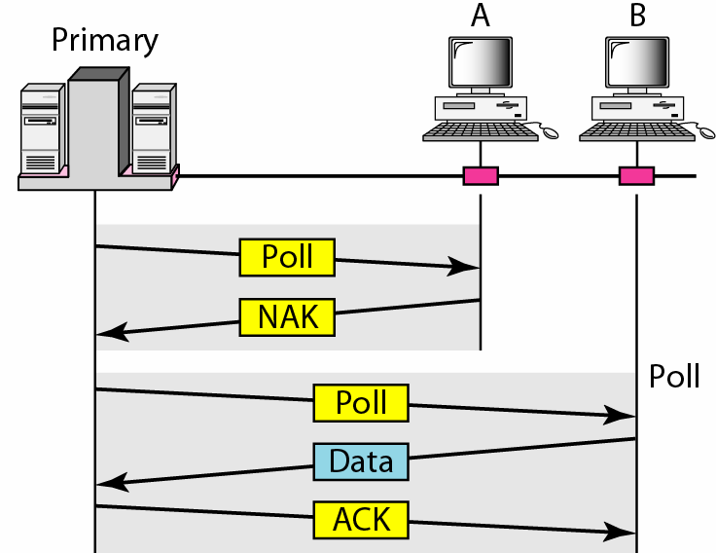
Figure No. 5
- What kind of access method is being used by the figure no. 5 shown above? What is happening in the figure? [4 marks]
- Explain the difference between 1-peristent method and non-persistent method in CSMA/CD. [4 marks]

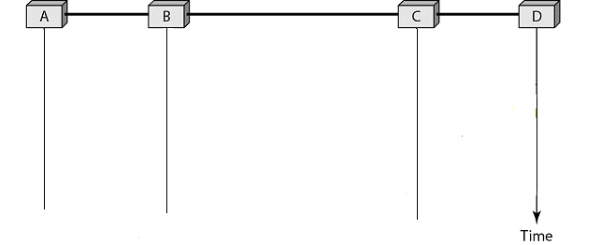
Figure No. 6
- The above figure no. 6 shows host A started transmitting at time t1=0, and host D at time t2=3 μsec using CSMA /CD. At some point there will be a collision between the two signals sent, why? What will Host D do after detecting the collision? [4 marks]

Question No. 7

- What are the phases in HDLC operation? Also mention which frames are used for each phase. [3 marks]
- Compare the control portion of an Information frame and Supervisory frame. (You can draw the control portions and label them properly for comparison.) [4 marks]

- HDLC uses bit stuffing or byte stuffing? What is the difference between the two?[3 marks]
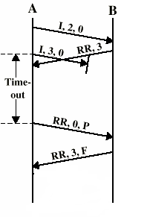
Figure No. 7
Step 2
Step 3
- Referring to figure no. 7 above, explain why host A sent a supervisory frame to host B rather than automatically resending the Information frame 3 after timeout? What will happen if host B had replied with RNR,3,F instead of RR,3,F? [5 marks]

Question No. 8

- Encode the following data stream 11100111 using Manchester and Bipolar AMI encoding methods. [4 marks]
- A system uses 6B/8B block coding and then Differential Manchester encoding scheme to encode the bits. Will this be an efficient system, explain why or why not? [4 marks]
- In Manchester encoding, there is a voltage transition in the middle of a bit, how does this transition help the encoding? Or does it create any problem? [3 marks]
- In 4B/5B block coding how are the 4 bits block substitute to 5 bits block? Do not show the exact mapping, but explain which type of 5 bits blocks are chosen and why?[4 marks]

THE END

